**Queensland Airports Limited**

**Position Description**

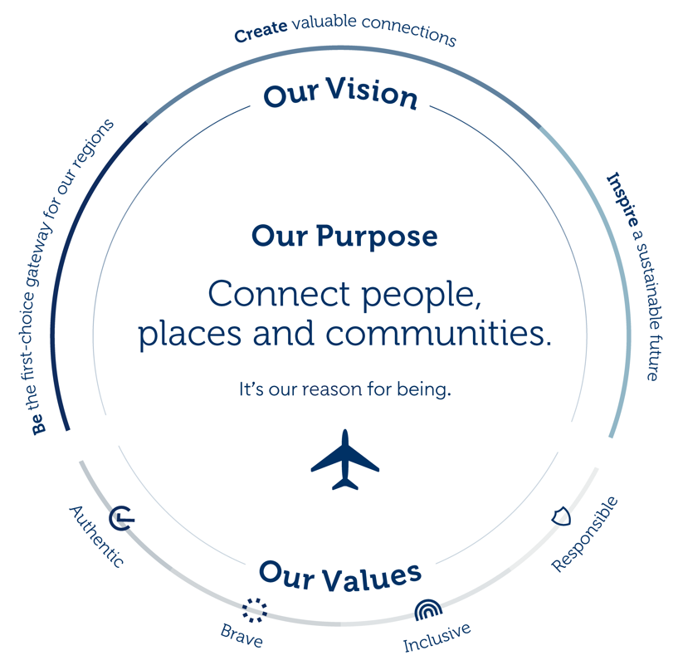

Our Vision defines our purpose. Our seven value drivers guide our strategic direction. Within each driver are strategies to deliver our goals and realise our vision. These strategies drive our existing business and underpin any acquisitions. Our Values influence the right behaviours when making decisions to achieve our Vision.

**Position Title:** Receptionist

**Location:** Gold Coast

**Department:** Administration

**Reports to:** People & Culture Manager

**Reporting to this position:** Nil

|  |
| --- |
| **Position Purpose** |

To provide a range of efficient reception and administration tasks that ensures an outstanding level of customer service at all times.

|  |
| --- |
| **Position Requirements** |

**Objective 1: Reception**

* Ensure the smooth running of reception and administration
* Greet visitors and manage sign in process
* Answer phone calls
* Maintain phone system i.e. voicemail messages, answering machine, messages
* Keep Reception area clean, tidy and welcoming

**Objective 2: Administration**

* Mail – responsible for mail collection, drop off, scanning and distribution
* Update phone lists, contact lists and other relevant lists that appear on QAL’s intranet site
* Undertake word processing, typing, binding, laminating, data entry and photocopying etc.
* Provide support as required by the P&C leader i.e support of the culture roadmap ie. Desk drop activiations, reward & recognition activities, diversity initiatives, celebrations.
* Co-ordinate couriers and receive deliveries
* Manage company general enquiries inbox and respond/forward all enquiries
* Ensure photocopiers and printers are in working order and stocked. Order supplies and log maintenance calls when necessary.
* Manage the care and maintenance of the company coffee machine
* Manage magazine subscription distribution
* Book travel as agreed with P&C Leader
* Order catering
* Manage appointments, photocopying etc. for ASIC processing
* Manage off site archiving of company records
* Receive PINS payments at Reception and forward to PINS Coordinator
* Order business cards and maintain stock levels of cards kept at reception
* Complete errands and other duties as requested
* Ensure Reception Manual is accurate and up to date at all times
* Responsibility for taking care of office areas, meeting rooms and kitchens

**Objective 3:** **Office Supplies/procurement**

* Ensure stationery and office supplies are monitored, ordered, delivered and distributed promptly
* Recycle items where appropriate and be mindful of opportunities to purchase environmentally friendly products
* Process Purchase Orders in accordance with QAL Procurement and Delegation Policies

**Objective 4: Crisis/ Project Participation / Innovation / Continuous Improvement**

* Build strong working relationships with internal and external stakeholders
* Effort is made to continuously maintain and improve the quality of WH&S procedures and tools for the site
* Look for opportunities within Reception to streamline and improve
* Ensure the Crisis management process/procedures are up to date as per Reception requirements and understand Reception responsibilities

**Objective 5: Project Participation / Innovation / Continuous Improvement**

* Build strong working relationships with internal and external stakeholders
* Effort is made to continuously maintain and improve the quality of WH&S procedures and tools for the site
* Actively engage and participate in all projects
* Continually strive to improve all processes, procedures and systems to enhance workplace efficiencies

**Objective 6: Workplace Health & Safety, Environmental and Aviation Safety & Security**

* Take reasonable care for your health and safety
* Take reasonable care for the health and safety of others including the implementation of risk control measures within your control to prevent injuries or illnesses
* Comply with any reasonable instruction in relation to WHS by the Company
* Co-operate with any reasonable policies and procedures of the QAL and associated entities including the reporting of hazards or incidents via the QAL reporting process
* All compliance requirements (e.g. legislative, policies, procedures) adhered to
* Other responsibilities as outlined in the QAL WHS management system
* Adhere to the locations Environmental Management System (EMS) as relevant to your work activities
* Attend EMS related training
* Adhere to relevant aviation safety and security requirements

|  |
| --- |
| **Behavioural Expectations for all QAL Employees** |

QAL employees are expected to demonstrate behaviour which is aligned to our core values:

**Authentic**

* We are true to ourselves and our communities.
* We build genuine connections and deliver on our promises with integrity.

**Brave**

* We dare to be different and inspire change.
* We pursue new opportunities with courage and challenge the status quo.

**Inclusive**

* We celebrate difference and empower one another.
* We value every perspective and recognise that diversity makes us stronger.

**Responsible**

* We lead the way with purpose.
* We are accountable for our decisions.

|  |
| --- |
| **Behavioural Objectives** |

Whether a team member without direct reports or an executive running a division, all employees at QAL lead in one way or another. They may lead self, lead others or lead business. As such within the Performance Conversations set each year, managers will seek to set clear behavioural expectations for your specific role on the year ahead. As a minimum expectation your role is expected to demonstrate the following behaviours aways when carrying out the role objectives:

**Team Member**

* Role model the QAL Values
* Establish and maintain strong relationships with internal and external stakeholders
* Perform with pride a broad range of tasks competently as per the role requirements
* Uphold WHS and Regulatory obligations and comply with all policies
* Focus on continuous improvement both for company and self (including self driven learning, ability to take and act on constructive feedback and solution focused conversations)
* Demonstrate proactive, positive involvement as part of the team
* Exhibit teamwork through providing excellent service, inclusive behaviours and help to others (internal and external)
* Present a positive professional image for the company at all times

|  |
| --- |
| **Key Stakeholders** |

**Internal:** Employees and management at all levels

**External:** Contractors, Consultants, Stakeholders and the Community

|  |
| --- |
| **Key Capabilities Required to Perform Position** |

**Professional Experience:**

* Experience in a service based industry highly desirable
* Experience in managing a busy reception and switchboard highly desirable

**Specific Job Knowledge, Skills and Abilities:**

* Professional, responsible, with an attitude that is service minded, positive and team-oriented
* Competency in administration tasks such as photocopying, preparing documents, binding, ordering office supplies, laminating, booking appointments and mail procedures
* Accurate typing speed (60wpm with 95% accuracy)
* Excellent interpersonal skills and the ability to deal patiently and sympathetically with all stakeholders
* Clear and friendly speaking voice
* Be able to multi task
* Strong organisational, time, task and priority management skills.
* Excellent personal presentation

**Certificates:**

* Certificate 3 in Business Administration (desirable)

**Physical Demands:**

* Must be able to perform the required physical and psychological demands of the role.

**ACKNOWLEDGMENT**

*I acknowledge that I have read and understood the key result areas described in this Position Description and agree to carry out my duties and responsibilities to the best of my ability.  I assert that there are no limitations on my ability to fully perform the position for the company. I also understand that at times I may be required to undertake other duties relevant to the position that are not listed in this statement. I acknowledge my employer’s right to alter this Position Description from time to time in accordance with company requirements.*

Name Date

Signature