Queensland Airports Limited

Role Description

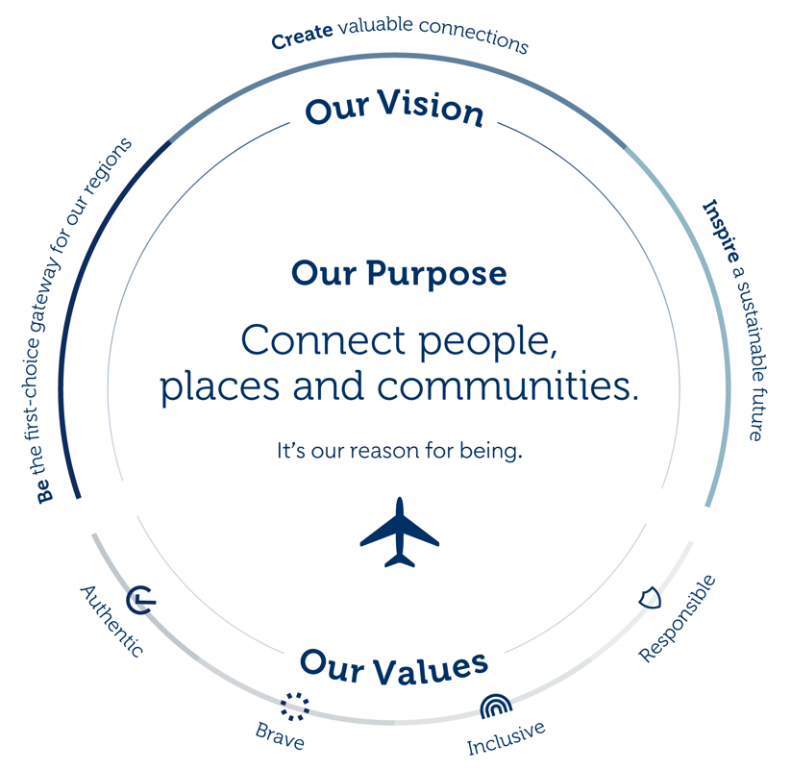

Our Vision defines our purpose. Our seven value drivers guide our strategic direction. Within each driver are strategies to deliver our goals and realise our vision. These strategies drive our existing business and underpin any acquisitions. Our Values influence the right behaviours when making decisions to achieve our Vision.

Position Title: Executive Assistant

Location: Gold Coast

Department: Administration

Reports to: Chief Financial Officer, Chief Legal Officer & Company Secretary

Reporting to this position: Nil

Position Purpose

Provide professional and comprehensive administrative support to the Chief Financial Officer (CFO) and the Chief Legal Officer & Company Secretary (CLOCS) with additional support to other teams and reception as required.

Position Requirements
Objective 1: Administration and Secretarial
- Provide high level administrative and secretarial support to the CFO, CLOCS and other members of the QAL Leadership team as required.
- Assist with the compilation, governance, and timely distribution of QAL Board and Committee papers, including supporting the Executive on agenda, quality control review of papers, process tracking, and timely distribution.
- Organisation of Executive meetings, QAL board and committee meetings, stakeholder events, visits from external stakeholders including document readiness and meeting logistics etc.
- Assist with the preparation of monthly reports, presentations, correspondence, submissions, briefing messages, media management etc.
- Diary and meeting management, telephone calls and management of correspondence.
- Draft, review and send communications on behalf of the Executive.
- Support email management including prioritising approvals and responses if requested by Executive
- Co-ordinate documents for signature.
- Domestic and international travel.
- Document and data filing (i.e., SharePoint filing)
- Adhoc research and projects.
- Provide additional support to the Executive Committee’s wider teams (including General Managers or for team activities) and reception as required. Focus of role will remain Executive support, and additional support should be agreed with Executive leader.
- Other administration duties as requested.

Objective 2: Finance
- Raise and ensure compliance to Purchase Orders.
- Complete monthly credit card reconciliations accurately and in a timely manner.
- Support with expense reconciliations ensuring compliance and timeliness of submission.
- Assist with the preparation of budgets.
- QAL Group Travel including quarterly and annual reviews and reconciliation of monthly account in coordination with Finance Department.

Objective 3: Project Participation / Innovation / Continuous Improvement
- Build strong working relationships with internal and external stakeholders
- Work together with the other Executive Assistants to support the Executive team to effectively engage and deliver on the organisation’s goals
- Continually strive to improve all processes, procedures, and systems to enhance workplace efficiencies.
- maintain and improve the quality of WH&S procedures and tools for the site.
- Actively engage and participate in projects as required.
- Every EA role has the same requirements and responsibilities including support and enablement of the Executive’s functional requirements. As such, there may be times the Executive Assistant will be assigned ownership of a functional requirements related to their Executive . (e.g., Assistance with updating corporate registers, additional governance support, ownership of a QAL event, communication support or messaging support).

Objective 4: Workplace Health and Safety (WHS), Environmental and Aviation Safety & Security
- Take reasonable care for your health and safety.
- Take reasonable care for the health and safety of others including the implementation of risk control measures within your control to prevent injuries or illnesses.
- Comply with any reasonable instruction in relation to WHS by the Company.
- Co-operate with any reasonable policies and procedures of the QAL and associated entities including the reporting of hazards or incidents via the QAL reporting process.
- All compliance requirements (e.g. legislative, policies, procedures) adhered to
- Other responsibilities as outlined in the QAL WHS management system.
- Adhere to the locations Environmental Management System (EMS) as relevant to your work activities, and attend EMS related training.
- Adhere to relevant aviation safety and security requirements.

Behavioural Expectations for all QAL Employees
QAL employees are expected to demonstrate behaviour which is aligned to our core values:

Authentic
- We are true to ourselves and our communities.
- We build genuine connections and deliver on our promises with integrity.

Brave
- We dare to be different and inspire change.
- We pursue new opportunities with courage and challenge the status quo.

Inclusive
- We celebrate difference and empower one another.
- We value every perspective and recognise that diversity makes us stronger.

Responsible
- We lead the way with purpose.
- We are accountable for our decisions.

Behavioural Objectives

Whether a team member without direct reports or an executive running a division, all employees at QAL lead in one way or another. They may lead self, lead others or lead business. As such within the Performance Conversations set each year, managers will seek to set clear behavioural expectations for your specific role on the year ahead. As a minimum expectation your role is expected to demonstrate the following behaviours aways when carrying out the role objectives:

Team Member
- Role model the QAL Values
- Establish and maintain strong relationships with internal and external stakeholders
- Perform with pride a broad range of tasks competently as per the role requirements
- Uphold WHS and Regulatory obligations and comply with all policies
- Focus on continuous improvement both for company and self (including self-driven learning, ability to take and act on constructive feedback and solution focused conversations)
- Demonstrate proactive, positive involvement as part of the team
- Exhibit teamwork through providing excellent service, inclusive behaviours and help to others (internal and external)
- Present a positive professional image for the company at all times

Key Stakeholders

Internal: Employees and management at all levels

External: Contractors, Consultants, Stakeholders, and the Community

Key Capabilities Required to Perform Role

Professional Experience:
- Experience in a similar Executive Assistant role (min. 3 years).
- Experience in providing administrative support to Executives and Board of Directors.
- Experience in preparing board and committee papers, executive reporting, and presentation.
- Experience in operating in a dynamic operational workplace.
- Demonstrated professional communication style.

Specific Job Knowledge, Skills, and Abilities:
- Software experience with various office computer packages e.g., Explorer, Word, Excel, Adobe, PowerPoint etc.
- Experience with SharePoint and Diligent Board Books would be highly desirable.
- Experience with Finance One (Tech One) and ideally LawVu (or similar) an advantage.
- Excellent written and communication skills.
- Experience in preparing reports, letters, presentations, correspondence.
- Experience in organising functions and meetings.
- Experience in dealing with highly confidential information.
- Accurate typing (speed 60 wpm with 95% accuracy).
- Strong organisational, time, task, and priority management skills.
- Strong internal and external customer service skills.
- Strong problem solving and decision-making skills.
- Ability to multitask.

Certificates:

Diploma of Business Administration (desirable)

Physical Demands:
- Must be able to perform required physical and psychological demands of the role.

ACKNOWLEDGMENT

I acknowledge that I have read and understood the key result areas described in this Role Description and agree to carry out my duties and responsibilities to the best of my ability. I assert that there are no limitations on my ability to fully perform the position for the company. I also understand that at times I may be required to undertake other duties relevant to the position that are not listed in this statement. I acknowledge my employer’s right to alter this Role Description from time to time in accordance with company requirements.

_________________________________ ____________________
Name Date

_________________________________
Signature

