### **Queensland Airports Limited**

#### **Position Description**

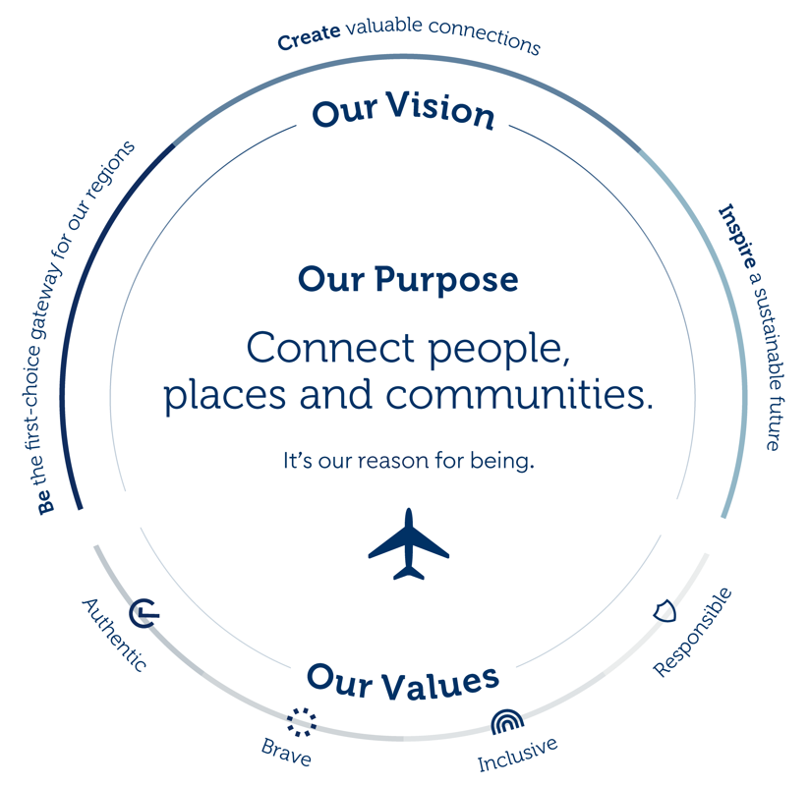

Our Vision defines our purpose. Our seven value drivers guide our strategic direction. Within each driver are strategies to deliver our goals and realise our vision. These strategies drive our existing business and underpin any acquisitions. Our Values influence the right behaviours when making decisions to achieve our Vision

**Position:** Environmental Advisor

**Location:** Gold Coast Airport

**Department:** QAL Health Safety and Environment

**Reports to:** QAL Environment Manager - Systems

**Position Purpose**

To manage the environmental obligations of Gold Coast Airport, with a focus on tenant and contractor compliance and water quality monitoring. This includes implementing and reviewing policies, procedures, and projects to ensure alignment with the QAL Environmental Management System (EMS), relevant legislation, and environmental standards.

**Position Requirements**

**Objective 1: Environment**

* Ensure compliance with the QAL EMS and strategic directions and integrate these into daily operations.
* Manage reviews of, and ensure implementation of, the Gold Coast Airport Environmental Strategy (AES) within the Master Plan, including annual reporting obligations to the Department of Infrastructure, Transport, Regional Development, Communications and the Arts.
* Liaise with the Airport Environment Officer on assigned management matters and provide required input to periodic meetings and reports.
* Develop, implement, and oversee tenant and contractor environmental management programs, including compliance monitoring, inspections, and audits.
* Conduct regular inspections of tenant and contractor activities to verify compliance, document findings, and issue corrective actions as required.
* Maintain records of tenant and contractor inspections, audits, and compliance performance within the EMS database.
* Review and assess tenant and contractor Environmental Management Plans (EMPs) for development and operational activities on airport land.
* Provide advice on tenant end-of-lease requirements, including remediation investigations.
* Represent and promote airport environmental interests in forums and maintain positive stakeholder relationships.
* Manage environmental monitoring programs (e.g. water, air, noise, soil) to ensure they address identified business objectives.
* Deliver environmental training and inductions for Gold Coast Airport staff, tenants, and contractors.
* Coordinate tendering and management of environmental consultancies.
* Support achievement of QAL environmental strategic outcomes by working with the QAL Environmental Systems Manager.
* Investigate, document, and respond to environmental incidents in line with QAL procedures, including tenant-related incidents.
* Assist with continuous review of the EMS, including internal audits, management reviews, and corrective action close-out.

**Objective 2: Administration**

* Maintain EMS databases.
* Maintain the environmental monitoring database.
* Maintain intranet and website environment pages.
* Ensure accurate record-keeping of inspections, audits, incident reports, and compliance monitoring outcomes.
* Ensure all environmental records are efficiently maintained and accessible.

**Objective 3: Project Participation / Innovation / Continuous Improvement**

* Build strong working relationships with internal and external stakeholders
* Effort is made to continuously maintain and improve the quality of WH&S procedures and tools for the site

**Objective 4: Workplace Health & Safety, Environmental and Aviation Safety & Security**

* Take reasonable care for your health and safety
* Take reasonable care for the health and safety of others including the implementation of risk control measures within your control to prevent injuries or illnesses
* Comply with any reasonable instruction in relation to WHS by the Company
* Co-operate with any reasonable policies and procedures of the QAL and associated entities including the reporting of hazards or incidents via the QAL reporting process
* All compliance requirements (e.g. legislative, policies, procedures) adhered to
* Other responsibilities as outlined in the QAL WHS management system
* Adhere to the locations Environmental Management System (EMS) as relevant to your work activities
* Attend EMS-related training
* Adhere to relevant aviation safety and security requirements

|  |
| --- |
| **Behavioural Expectations for all QAL Employees** |

QAL employees are expected to demonstrate behaviour which is aligned to our core values:

**Authentic**

* We are true to ourselves and our communities.
* We build genuine connections and deliver on our promises with integrity.

**Brave**

* We dare to be different and inspire change.
* We pursue new opportunities with courage and challenge the status quo.

**Inclusive**

* We celebrate difference and empower one another.
* We value every perspective and recognise that diversity makes us stronger.

**Responsible**

* We lead the way with purpose.
* We are accountable for our decisions.

|  |
| --- |
| **Behavioural Objectives** |

Whether a team member without direct reports or an executive running a division, all employees at QAL lead in one way or another. They may lead self, lead others or lead business. As such within the Performance Conversations set each year, managers will seek to set clear behavioural expectations for your specific role on the year ahead. As a minimum expectation your role is expected to demonstrate the following behaviours aways when carrying out the role objectives:

**Exco/General Manager**

* Provide strategic direction & leadership to guide, protect and enhance the future profitable and sustainable growth of the company (customer, shareholder, employee)
* Drive a positive culture of high performance, inclusivity and safety
* Contribute to the economic, social and environmental health of the communities in which QAL resides
* Role model the QAL Values
* Establish and maintain strong relationships with internal and external stakeholders
* If applicable – uphold the duties as an officer of the company

**Senior Manager (Generally this role is a direct report to a GM)**

* Role model the QAL Values
* Establish and maintain strong relationships with internal and external stakeholders
* Demonstrate proactive, positive involvement as part of the team
* Provide clear expectations through setting individual and team goals
* Give regular feedback and recognition to employees for high performance
* Maximise development, performance, engagement and retention of team
* Communicate regularly to the team on what is going on in the business
* Display inclusive leadership and leverage the diverse mix of the team’s strengths and talents
* Lead the delivery of business strategy and projects
* Manage the budget and required financial requirements
* Ensure compliance and all regulatory obligations are met by the team
* Promote innovation, teamwork and cross company exchange of ideas for shareholder value i.e. revenue & customer excellence
* Support the delivery of ESG

**Manager**

* Role model the QAL Values
* Establish and maintain strong relationships with internal and external stakeholders
* Perform with pride a broad range of tasks competently as per the role requirements
* Uphold WHS and Regulatory obligations and comply with all policies
* Focus on continuous improvement both for company and self (including self driven learning, ability to take and act on constructive feedback and solution focused conversations)
* Demonstrate proactive, positive involvement as part of the team
* Exhibit teamwork through providing excellent service, inclusive behaviours and help to others (internal and external)
* Present a positive professional image for the company at all times
* Provide clear expectations through setting individual and team goals
* Give regular feedback and recognition to employees for high performance

**Supervisor /Team leader**

* Communicate regularly to the team on what is going on in the business
* Role model the QAL Values
* Establish and maintain strong relationships with internal and external stakeholders
* Perform with pride a broad range of tasks competently as per the role requirements
* Uphold WHS and Regulatory obligations and comply with all policies
* Focus on continuous improvement both for company and self (including self driven learning, ability to take and act on constructive feedback and solution focused conversations)
* Demonstrate proactive, positive involvement as part of the team
* Exhibit teamwork through providing excellent service, inclusive behaviours and help to others (internal and external)
* Present a positive professional image for the company at all times
* Provide clear expectations through setting individual and team goals
* Give regular feedback and recognition to employees for high performance
* Communicate regularly to the team on what is going on in the business

**Team Member**

* Role model the QAL Values
* Establish and maintain strong relationships with internal and external stakeholders
* Perform with pride a broad range of tasks competently as per the role requirements
* Uphold WHS and Regulatory obligations and comply with all policies
* Focus on continuous improvement both for company and self (including self driven learning, ability to take and act on constructive feedback and solution focused conversations)
* Demonstrate proactive, positive involvement as part of the team
* Exhibit teamwork through providing excellent service, inclusive behaviours and help to others (internal and external)
* Present a positive professional image for the company at all times

**Key Stakeholders**

*Internal:*Staff at all levels

*External:*Specialist contractors, regulatory authorities, consultants, equipment suppliers

**Key Capabilities Required to Perform Role**

**Essential**

* Tertiary qualifications in Environmental Science, Environmental Engineering or Environmental Management, or equivalent.
* Demonstrated experience in the implementation of management systems.
* Ability to work independently and manage the environmental aspects of airport work, including inspections, monitoring and reporting.
* Demonstrated skills in establishing work priorities, time management and project management.
* Highly developed oral and written communication skills.
* High level of computer literacy.
* Current Queensland Drivers license.
* Eligibility to hold an Aviation Security Identification Card and pass an Australian Federal Police Check.
* Excellent interpersonal and communication skills
* Self-motivated, energetic and diplomatically assertive

**Desirable**

* Demonstrated experience in airport operations.
* Geographical information system experience.
* Systems auditing experience.
* Demonstrated experience in applying risk management principles in an operational working environment.

**Specific Job Knowledge, Skills and Abilities:**

* Good written and verbal skills
* Good problem solving, decision making and negotiation skills
* Good organisational, time, task, planning and priority management skills
* General computer literacy (Word, Excel, Internet, Email)
* High level of attention to detail

**Physical Demands:**

* Must be able to perform the required physical and psychological demands of the role.

# ACKNOWLEDGEMENT

*I acknowledge that I have read and understood the key result areas described in this Role Description and agree to carry out my duties and responsibilities to the best of my ability.  I assert that there are no limitations on my ability to fully perform the position for the company. I also understand that at times I may be required to undertake other duties relevant to the position that are not listed in this statement. I acknowledge my employer’s right to alter this Role Description from time to time in accordance with company requirements.*

Name Date

Signature